CS 255 System Design Document Template

UML Diagrams

UML Use Case Diagram
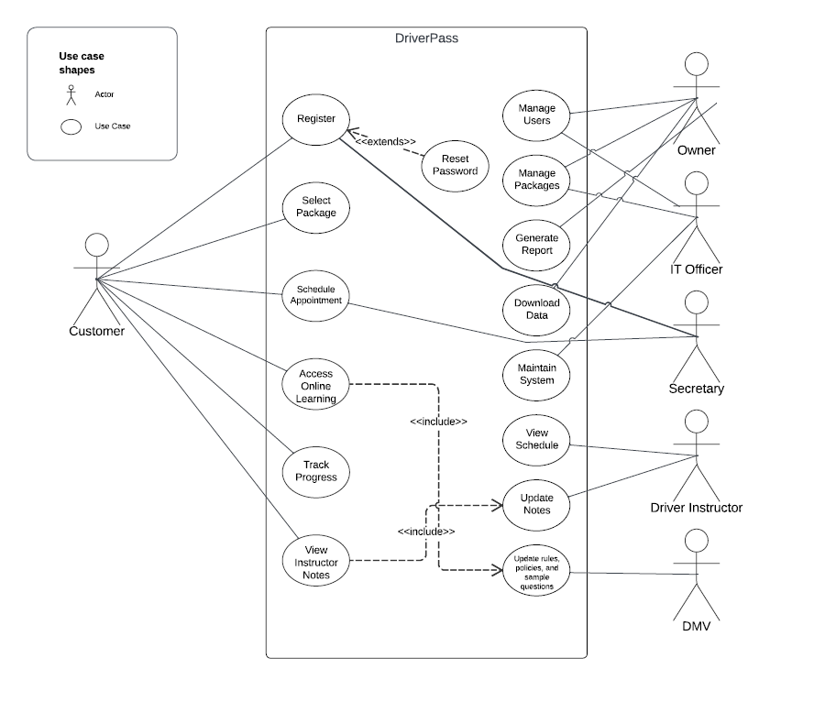

UML Activity Diagrams
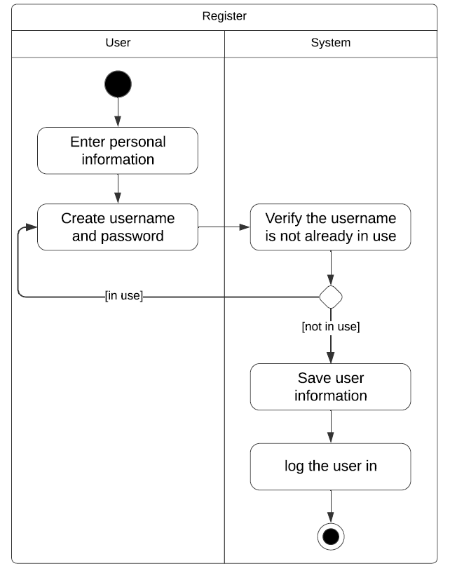
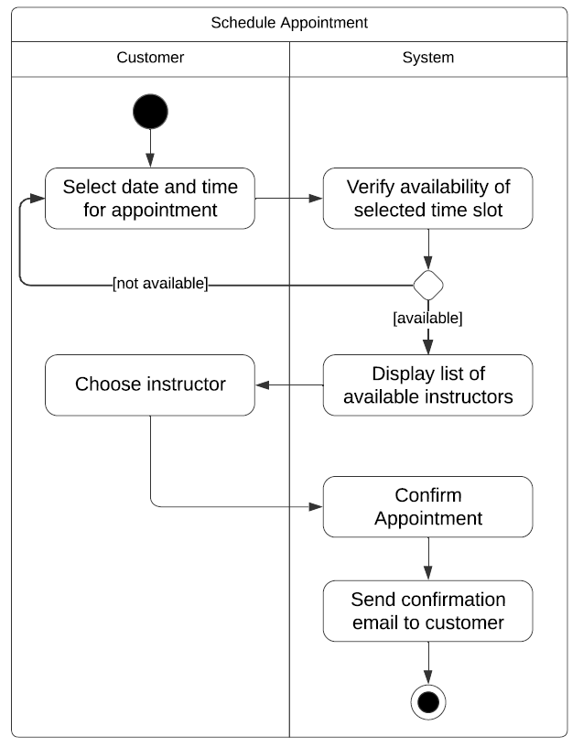

UML Sequence Diagram
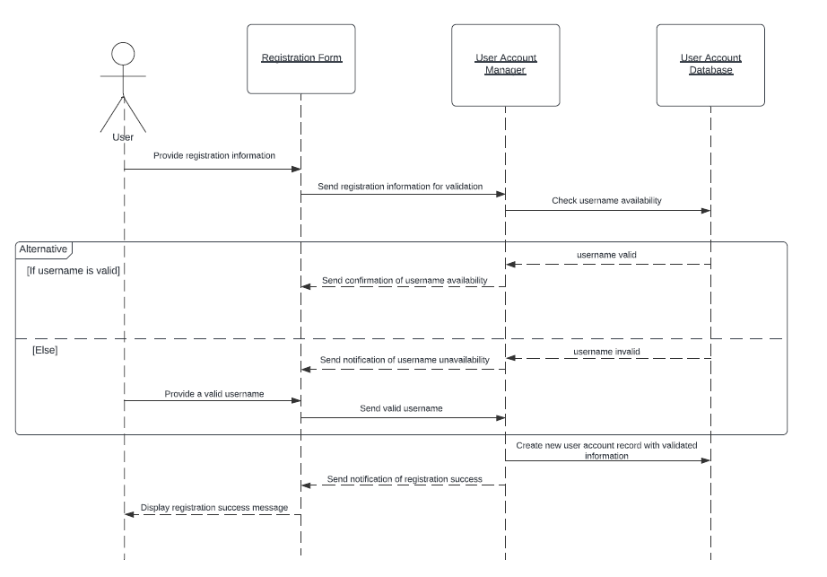

UML Class Diagram
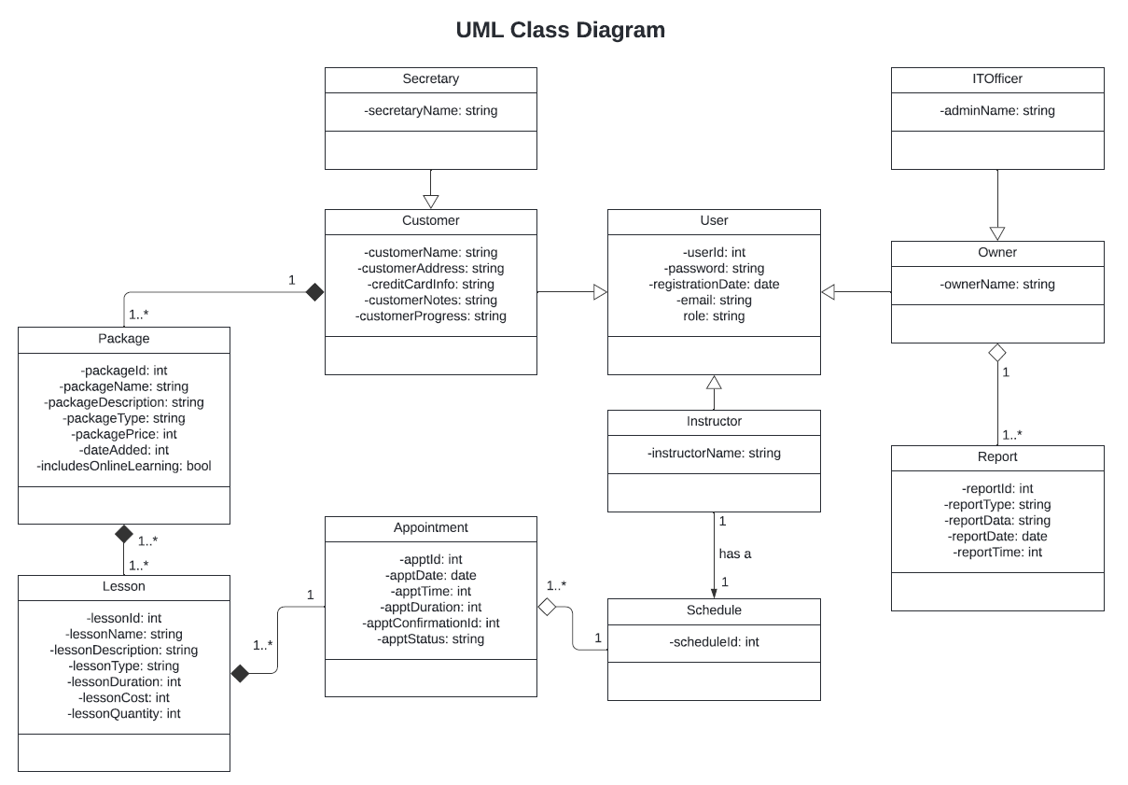

Technical Requirements
Based on the diagrams, the technical requirements are as follows:
Hardware:
- Server: A dependable server with sufficient processing power, memory, and storage capacity. Server must be able to handle traffic, database operations, and report generation.
- Network: Routers and switches to facilitate communication between the server and client devices.
- Internet: Both the server and client devices need a stable connection to enable user access and data exchange.
Software:
- Server-side operating system: An operating system that will provide stability and security features.
- Web Application Framework: A framework to streamline development and that provides user management and data access control.
- Database Management System: A relational database that is well-suited for storing user data, lesson information, package details, and report data.
Development Tools:
- Version Control: The development progress will need to be tracked and managed.
- IDE: An agreed upon integrated development environment that can enhance developer productivity.
- Testing Tools: Unit testing frameworks that can automate tests to ensure code quality and functionality.
Infrastructure:
- Web Server: A server that will host the DriverPass web application and make it accessible to users over the internet.
- Cloud: A cloud platform that can manage the server, database, and other components for simplified maintenance.
- Security Measures: Firewalls, Detection systems, and data encryption. There will be a lot of user data that needs to be protected.
- Scalability: The system should be designed to accommodate future growth.

